

**TUNKU ABDUL RAHMAN UNIVERSITY OF MANAGEMENT & TECHNOLOGY**

**Faculty of Applied Sciences**

**Faculty of Computing and Information Technology**

**Faculty of Built Environment**

**Faculty of Communication and Creative Industries**

**Faculty of Social Science and Humanities**

***Bachelor of Science (Hons)***

***Bachelor of Arts (Hons)***

**Academic Year 2023/24**

**MPU-3232 ENTREPRENEURSHIP**

**Coursework Specifications**

|  |  |  |  |
| --- | --- | --- | --- |
| **Assessment Methods** | | | **Total** |
| **Coursework** | | | **100%** |
| 1. | Idea Generation | 20 marks |
| 2. | Student Pitching | 30 marks |
| 3. | Business Plan Report | 50 marks |
| **TOTAL** | | **100 marks** |

**INTRODUCTION**

It is the requirement from Ministry of Education that all Malaysian and non-Malaysian students to complete the General Studies (MPU – Mata Pelajaran Pengajian Umum) as pre-requisite for the award of an undergraduate degree. This assignment is a partial fulfillment of the stated requirement for an undergraduate taking the subject in Entrepreneurship. This assignment is divided into 3 parts which are idea generation, business plan and student pitching.

**OBJECTIVES**

The objectives of this assignment are to assess student’s ability to:

1. **Understand** the different methods of ideas generation and **apply** in creating a transformational business. (C2, PLO2)

2. **Describe** the critical functional areas and **present** in a well-written business plan by gathering related materials through the available sources. (A1, PLO10)

3. **Propose** the new venture idea and business plan to potential financiers and/or investors. (A3, PLO11)

**LATE SUBMISSION**

All assignments should be submitted by the stated due date unless as revised and approved by the lecturer. It is the responsibility of the students to ensure that the assignment is substantially prepared prior to the submission date. As a general rule of thumb, no extension of time will be granted. The assignments and its due dates are normally given in advanced to students so that they have ample time to organize their study program. Please refer to **TAR UMT Guideline of Late Submission Coursework**.

**ASSIGNMENT POLICY**

All works presented for assessment are expected to be the student’s own and original work. The lecturer expects of all students, honest and meticulous acknowledgement of all sources of materials used.

**PLAGIARISM**

All work submitted must be original and not previously submitted for assessment at this University College or elsewhere. All information from other sources must be duly acknowledged. In particular, you need to cite by using **American Psychological Association (APA) style** sources discovered on the Internet or any other publications. Plagiarism is a breach of the University College regulations and may result in a mark of zero being given for the work containing plagiarism. Plagiarism includes copying from another source without acknowledging that source, whether it can be the work of another student, an author or of your own assignment for another course. Students found to have plagiarised other works will record a failure in the subject.

Given the explosion of electronic publications in recent years, students need to be careful that their assignments do not become an exercise in cutting and pasting existing abstracts or portions of World Wide Web pages. Rarely will such an approach produce acceptable results.

The student is required to submit the report to **Turnitin** to check for plagiarism. If the plagiarised percentage is more than the acceptable percentage, the student has to modify the assignment report until it is below the acceptable percentage before submission otherwise it will be considered as a plagiarised material. Remember to attach along the report (**the first page only**) generated by Turnitin software as a proof of your originality work.

**QUESTION:**

THE Malaysian economy is expected to strengthen in 2024, growing in the range of 4% to 5% amid expansion in all sectors and better prospects in global trade.

In its Economic Outlook 2024 report, the Finance Ministry said that world trade is likely to improve next year in tandem with stronger trade activities.

This in turn would benefit Malaysia, whose economy is heavily dependent on trade.

The Finance Ministry also said that efforts will be intensified to strengthen Malaysia's agility in keeping pace with the fast-changing environment.

This would require a paradigm shift and innovation culture to enhance economic growth, it added.

“The continuation of strategic projects, digitalisation, improved productivity and advanced manufacturing will further stimulate the growth of the economy in the medium term.

“All economic sectors are expected to benefit from the recent policies such as the National Energy Transition Roadmap, the New Industrial Master Plan 2030 and the Medium-Term Review of the 12th Malaysia Plan, which are in tandem with the Ekonomi Madani framework,” the ministry said.

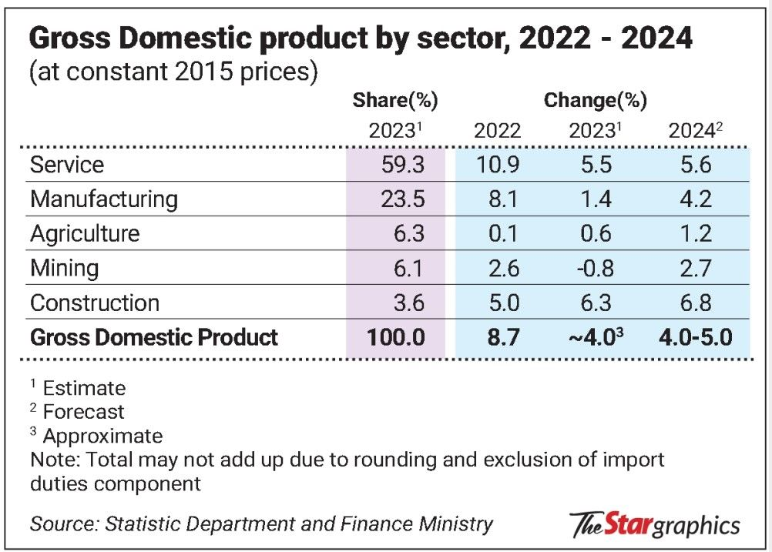

Breaking down by economic sectors, the Finance Ministry forecast the services sector to grow by 5.6% in 2024, driven by expansion in all subsectors.

In addition, vibrant tourism-related activities as well as continuous consumer spending are expected to further spur the growth of the sector.

In comparison, the services sector is projected to grow by 5.5%.

Meanwhile, the manufacturing sector is expected to expand by 4.2% next year, as compared to 1.4% in 2023.

The improved growth rate is driven by improved performance in both export- and domestic-oriented industries.

The export-oriented industries are expected to benefit from the recovery of external demand with the electrical and electronics segment projected to surge, primarily driven by memory products.

Similarly, domestic-oriented industries are anticipated to grow steadily, backed by higher output in transport- and construction-related segments, in tandem with better consumer spending and business activities.

The agriculture sector is poised to grow by 1.2% in 2024, as compared to 0.6% this year, driven by expansion in most subsectors, particularly oil palm, other agriculture and livestock.

With minimal impact expected from the El Nino phenomenon and labour conditions returning to pre-pandemic level, the oil palm production is projected to increase.

“Furthermore, increased matured areas especially in Peninsular Malaysia and higher oil extraction rate arising from more frequent harvesting rounds are also expected to support the subsector's growth,” stated the Finance Ministry.

It further added the crude palm oil price is forecast to average within the range of RM4,000 and RM4,500 per tonne in 2024, as compared to 2023’s average of RM3,500 to RM4,000 per tonne.

<https://www.thestar.com.my/business/business-news/2023/10/13/economy-to-improve-in-2024>

**REQUIREMENTS:**

**PART 1: IDEA GENERATION**

**MARK: 20%**

**DATELINE: Week 4**

Select a type of business that your group is interested in and report to your Tutor. No **TWO (2)** groups are allowed to choose the same business. Privilege will be given to the first group that report to the tutor. Example of the industries that can be chosen:

* Food and beverage
* Education
* Computer/IT
* Tourism
* Clothing/Apparel
* Fast moving consumer products
* Health care and Skin/beauty care
* Others (subject to approval by Lecturer or Tutor)

Note: You may also refer to the selected United Nations’ Sustainable Development Goals shown below as guidelines for Idea Generation.

* Zero hunger
* Good health and well-being
* Clean water and sanitation
* Affordable and clean energy
* Decent work and economic growth
* Industry, innovation and infrastructure
* Sustainable cities and communities
* Responsible consumption and production

Students are required to:

(i) Work in a team of 4 – 5 members (depend on the size of the tutorial group),

(ii) Access the social issues happening in Malaysia,

(iii) Brainstorm in a team for potential idea and

(iv) Propose the new and innovative idea (product/ service) to the respective tutor.

**PART 2: BUSINESS PLAN**

**MARK: 50%**

**DATELINE: Week 12**

**MAXIMUM ACCEPTED PLAGIARISED PERCENTAGE: 15%**

Students are required to prepare a comprehensive business plan outlining the future activity of the

proposed business venture. The elements in the business plan are as follow:

* + Executive Summary
  + Business Description
  + Industry Analysis
  + Market Analysis
  + Marketing Plan
  + Operational Plan
  + Financial Projection

**Format of documentation includes:**

• This written assignment **SHOULD NOT** exceeds 5,000 words in length (excluding the Cover page, Plagiarism Declaration Statement page, Assessment Criteria page, Projected Financial Statements, References and Bibliography page(s), and Appendices)

• This assignment should use font size 12, Times New Roman, 1.5 Line Spacing and with justified alignment.

• Cover page – refer to Attachment 1.

• Plagiarism statement – refer to Attachment 2.

• Assessment criteria: Idea Generation – refer to Attachment 3.

• Assessment criteria: Business Plan – refer to Attachment 4.

• Assessment criteria: Idea Pitching – refer to Attachment 5.

**Part 3: IDEA PITCHING**

**MARK: 30%**

**DATELINE: Week 12 and 13**

**ATTIRE: Formal**

The students are required to pitch about their group assignment idea to their tutor. It is **COMPULSORY**

for **ALL** the group members to participate in presenting their idea during the pitching session. The pitching

session will be divided into 2 parts: (i) Idea Pitching (15 minutes) and (ii) Question and Answer (5 minutes).

**Attachment 1 (Cover Page)**



**TUNKU ABDUL RAHMAN UNIVERSITY OF MANAGEMENT & TECHNOLOGY**

**<Faculty Name>**

**<Programme>**

**<Year of Study>**

**MPU-3232 Entrepreneurship Assignment**

**Academic Year 2023/24**

|  |  |  |  |  |  |
| --- | --- | --- | --- | --- | --- |
| **Student Names** | **Student ID**  **No** | **Idea Generation (20%)** | **Business**  **Plan (50%)** | **Idea Pitching (30%)** | **Total**  **(100%)** |
|  |  |  |  |  |  |
|  |  |  |  |  |  |
|  |  |  |  |  |  |
|  |  |  |  |  |  |
|  |  |  |  |  |  |

**Attachment 2 (Plagiarism Statement)**

**<Faculty Name>**

**PLAGIARISM STATEMENT**

**MPU-3232 ENTREPRENEURSHIP**

Semester : _____________________________

Programme : _________________________________________________

Tutorial Group: _____________________________

**Declaration**

I/We confirm that I/we have read and shall comply with all the terms and conditions of TAR University College’s plagiarism policy.

I/We declare that this assignment is free from all forms of plagiarism and for all intents and purposes is my/our own properly derived work.

|  |  |  |  |
| --- | --- | --- | --- |
| **No** | **Students’ Names** | **Students’ ID No** | **Signature** |
| 1. |  |  |  |
| 2. |  |  |  |
| 3. |  |  |  |
| 4. |  |  |  |
| 5. |  |  |  |

**Attachment 3 (Assessment Criteria: Idea Generation)**

**Assessment Criteria: Idea Generation**

|  |  |  |
| --- | --- | --- |
| **CLO Assessed: 1** | **PLO Assessed: 2** | **MQF Cluster of LO: Cognitive Skill** |

|  |
| --- |
| **Idea Proposed:** |

|  |  |  |  |  |  |
| --- | --- | --- | --- | --- | --- |
| **Criteria (Total Mark: 20 marks)** | **Category** | | | | **Mark** |
| **Excellent**  **(Mark: 5)** | **Good**  **(Marks: 3 – 4)** | **Average**  **(Mark: 2)** | **Poor**  **(Marks: 0 – 1)** |
| **1. Variety of Ideas and Contexts (Score: 5 marks)**  • Ideas represent important concepts.  • Ideas generated are from different contexts or disciplines.  • Ideas proposed are relevant to the chosen area. | **ALL** sub-criteria are met | Only **TWO (2)** sub-criteria are met | Only **ONE (1)**  sub-criteria is  met | **NO** sub-criteria is met |  |
| **2. Variety Sources (Score: 5 marks)** • Idea proposed is exhibiting a good amount of research has been done. • Idea suggested is based on mixture of different sources such as texts, media or resource person.  • Personal experience or opinions are included in generating the idea. | **ALL** sub-criteria are met | Only **TWO (2)** sub-criteria are met | Only **ONE (1)**  sub-criteria is  met | **NO** sub-criteria is met |  |
| **3. Combining Idea (Score: 5 marks)** • Idea is combined in original and surprising way.  • Idea proposed is logical and feasible. • Idea suggested is addressing the issue/ solving the problem. | **ALL** sub-criteria are met | Only **TWO (2)** sub-criteria are met | Only **ONE (1)**  sub-criteria is  met | **NO** sub-criteria is met |  |
| **4. Communicating Something New (Score: 5 marks)**  • Idea created is interesting, new and helpful.  • Idea is adding value to the current pool of solutions.  • Idea propose can identify a previously unknown problem, issue or purpose. | **ALL** sub-criteria are met | Only **TWO (2)** sub-criteria are met | Only **ONE (1)**  sub-criteria is  met | **NO** sub-criteria is met |  |
| **TOTAL MARK (OUT OF 20)** | | | | |  |

*Source: From How to Create and Use Rubrics for Formative Assessment and Grading (p. 54), by Susan M. Brookhart, 2013, Alexandria, VA: ASCD.*

http://www.ascd.org/publications/educational-leadership/feb13/vol70/num05/Assessing-Creativity.aspx

**Attachment 4 (Assessment Criteria: Business Plan)**

**Assessment Criteria: Business Plan**

|  |  |  |
| --- | --- | --- |
| **CLO Assessed: 2** | **PLO Assessed: 7** | **MQF Cluster of LO: Entrepreneurial Skill** |

|  |  |  |  |  |  |
| --- | --- | --- | --- | --- | --- |
| **Criteria** | **Category** | | | | **Mark** |
| **Excellent** | **Good** | **Average** | **Poor** |
| **Executive Summary (Score: 10 marks)**  • Brief overview of the document that highlights its  main points.  • It must be **clear**, **concise** and end with **a call to action.** | **ALL** sub criteria are met.  (8 – 10) | Only **TWO (2)** sub-criteria are met.  (6 – 7) | Only **ONE (1)** sub-criteria is met.  (4 – 5) | **NO** sub-criteria is met.  (0 – 3) |  |
| **2. Business Description (Score: 5 marks)** • Company vision and mission  • Company background  • Nature of the business | **ALL** sub criteria are met.  (5) | Only **TWO (2)** sub-criteria are met.  (4) | Only **ONE (1)** sub-criteria is met.  (2 – 3) | **NO** sub-criteria is met.  (0 – 1) |  |
| **3. Market Analysis (Score: 20 marks)** • Industry analysis  • Competitors analysis  • PEST & SWOT analysis | **ALL** sub criteria are met.  (16 - 20) | Only **TWO (2)** sub-criteria are met.  (13 – 15) | Only **ONE (1)** sub-criteria is met.  (8 – 12) | **NO** sub-criteria is met.  (0 – 7) |  |
| **4. Marketing Plan (Score: 20 marks)**  • Target Market  • Marketing mix (4P’s)  • Marketing Implementation plan  • Marketing Strategies | **ALL** sub criteria are met.  (16 - 20) | Only **THREE (3)** sub-criteria are met.  (13 – 15) | Only **TWO (2)** sub-criteria is met.  (8 – 12) | **NO** sub-criteria is met.  (0 – 7) |  |
| **5. Operational Plan (Score: 10 marks)**  • Legal and licensing requirements, management details, organizational structure and professional advisers  • Insurance and security needs and critical risks and  contingency plans.  • Business premises and plant and equipment andneeded and business processes. | **ALL** sub criteria are met.  (8 - 10) | Only **TWO (2)** sub-criteria are met.  (6 – 7) | Only **ONE (1)** sub-criteria is met.  (4 – 5) | **NO** sub-criteria is met.  (0 – 3) |  |
| **6. Financial Plan (Score: 20 marks)**  • Projected start-up expenditure  • Projected profit/loss (3 years)  • Balance sheet statements and cash flow statement (3 years) | **ALL** sub criteria are met.  (16 - 20) | Only **TWO (2)** sub-criteria are met.  (13 – 15) | Only **ONE (1)** sub-criteria is met.  (8 – 12) | **NO** sub-criteria is met.  (0 – 7) |  |
| **7. Originality (Score: 10 marks)**  • Citations and referencing  • Turnitin report | Clear and proper citations and with at least 15 referencing with Turnitin report attached.  (9 - 10) | Clear and proper citations with less than 15 referencing with Turnitin report attached.  (6 - 8) | Clear and proper citations with less than 10 referencing with Turnitin report attached.    (4 - 5) | Unclear and improper  Citations, no referencing and without Turnitin report attached.  (0 - 3) |  |
| **8. Report Layout and Format (Score: 5 marks)** | Professional  format and structure.  Logically  arranged  (5) | Clear and recognizable  format with an adequate logical structure.  (4) | Recognizable  format and structure,  although  occasionally  unclear. (2 – 3) | Little attempt to use the appropriate  format or to structure  content. (0 – 1) |  |
| **TOTAL MARK (OUT OF 100)** | | | | |  |
| **TOTAL MARK (OUT OF 50)** | | | | |  |

**Attachment 5 (Assessment Criteria: Idea Pitching)**

**Assessment Criteria: Idea Pitching**

|  |  |  |
| --- | --- | --- |
| **CLO Assessed: 3** | **PLO Assessed: 4** | **MQF Cluster of LO: Communication Skill** |

|  |  |  |  |  |
| --- | --- | --- | --- | --- |
| **Criteria (Total Mark: 60 marks)** | **Category** | | | |
| **Excellent**  **(Marks: 10 – 12)** | **Good**  **(Marks: 7 – 9)** | **Average**  **(Marks: 4 – 6)** | **Poor**  **(Marks: 0 – 3)** |
| 1. **Content/ Structure (Score: 12 marks)**   • Presentation is well-structured and each section  is well-connected with smooth transition.  • Clearly defined pain point and well-formulated solution has been proposed.  • All the materials presented are relevant and supported with clear explanation. | **ALL** sub-criteria are met | Only **TWO (2)** sub  criteria are met | Only **ONE (1)** sub  criteria is met | **NO** sub-criteria is met |
| **2. Eloquent (Score: 12 marks)**  • Portray a good level of confidence by maintaining poised and composure.  • Exhibit high level of enthusiasm and passion about the idea.  • Strong closing (using powerful quote, asking rhetorical question, including a call to action etc) | **ALL** sub-criteria are met | Only **TWO (2)** sub  criteria are met | Only **ONE (1)** sub  criteria is met | **NO** sub-criteria is met |
| **3. Delivery/ Audience Awareness (Score: 12 marks)**  • Fluent delivery of speech was demonstrated in variations of tone, appropriate speaking volume and managing pace effectively.  • Proper posture and gestures exhibit a good level of confidence.  • Maintaining regular/ constant eye contact to increase audiences’ engagement. | **ALL** sub-criteria are met | Only **TWO (2)** sub  criteria are met | Only **ONE (1)** sub  criteria is met | **NO** sub-criteria is met |
| **4. Media Used (Score: 12 marks)**  • Well-designed visual aid with clear, concise and relevant information being presented on each slide.  • Visually appealing slides with balanced use of different elements.  • Evident of creative effort in making the visual aid more captivating. | **ALL** sub-criteria are met | Only **TWO (2)** sub  criteria are met | Only **ONE (1)** sub  criteria is met | **NO** sub-criteria is met |
| **5. Question and Answer (Score: 12 marks)**  • Listen to questions attentively.  • Formulate the answer in a composed state.  • Demonstrate a good level of mastery of the subject knowledge in the answer presented. | **ALL** sub-criteria are met | Only **TWO (2)** sub  criteria are met | Only **ONE (1)** sub  criteria is met | **NO** sub-criteria is met |

**Instruction: Fill in the relevant mark for each presenter by referring to the Assessment Criteria as shown above**

|  |  |  |  |  |  |
| --- | --- | --- | --- | --- | --- |
| **Criteria** | **Presenter Name** | | | | |
|  |  |  |  |  |
| **1. Content/ Structure**  **(12 marks)** |  |  |  |  |  |
| **2. Eloquent**  **(12 marks)** |  |  |  |  |  |
| **3. Delivery/ Audience Awareness (12 marks)** |  |  |  |  |  |
| **4. Media Used**  **(12 marks)** |  |  |  |  |  |
| **5. Question and Answer**  **(12 marks)** |  |  |  |  |  |
| **TOTAL MARK (OUT OF 60)** |  |  |  |  |  |
| **TOTAL MARK (OUT OF 30)** |  |  |  |  |  |

**FEEDBACK:**